**Install OpenIPC in GOKE ( GK7205v210 ) - Windows 10**

Minimum Hardware Required  
  
1) UART to USB (FTDI)

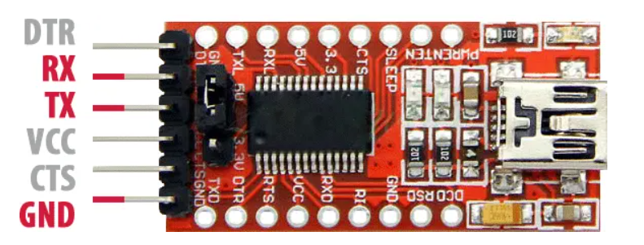

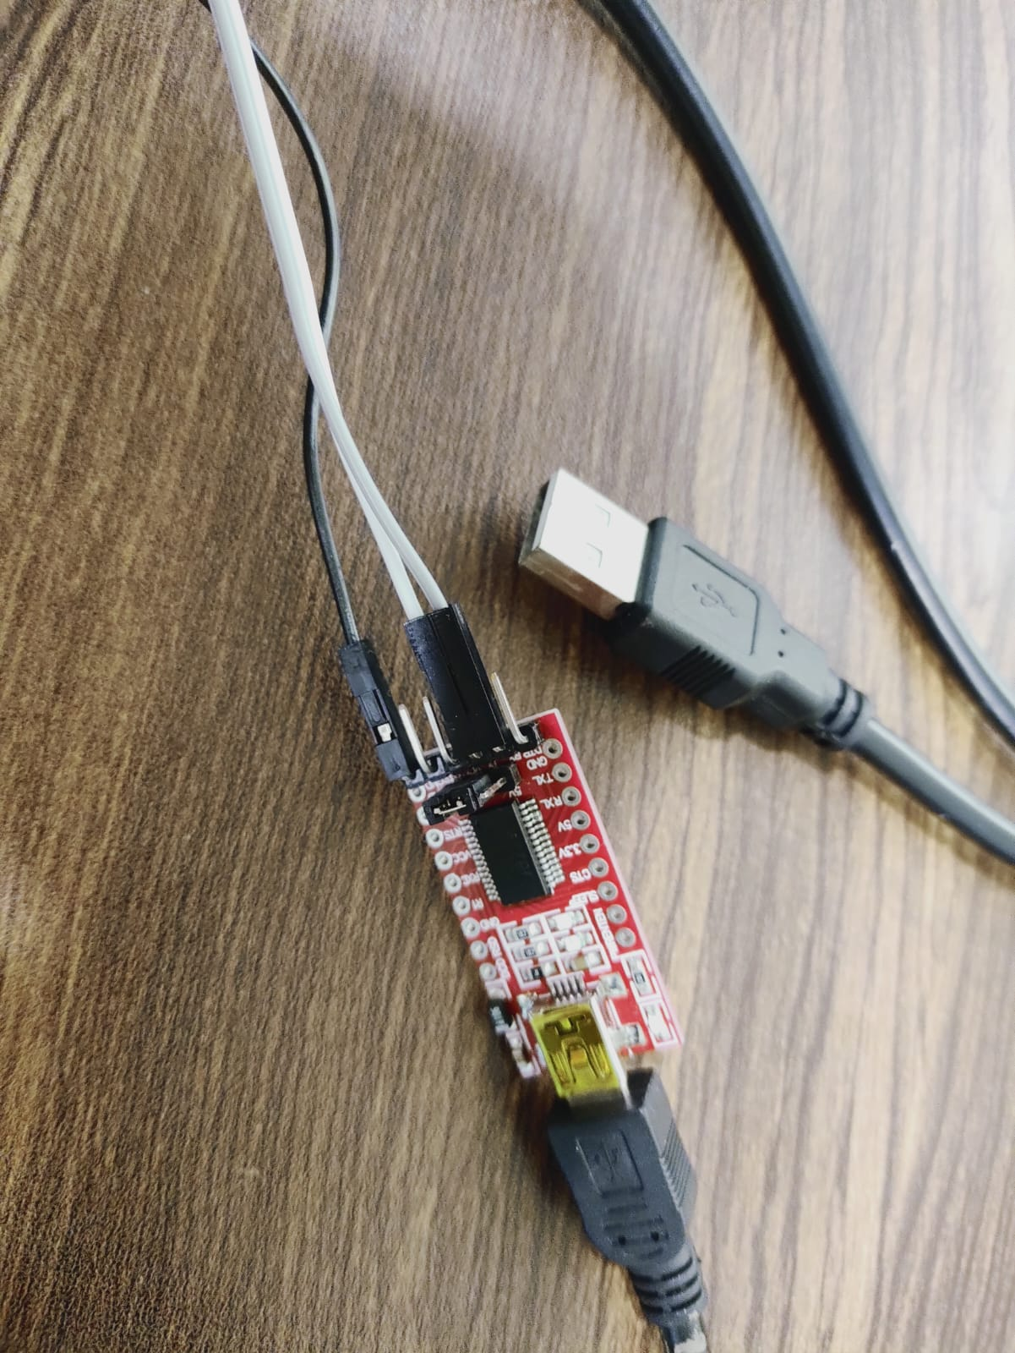

2) Camera PCB (with Goke Processor)

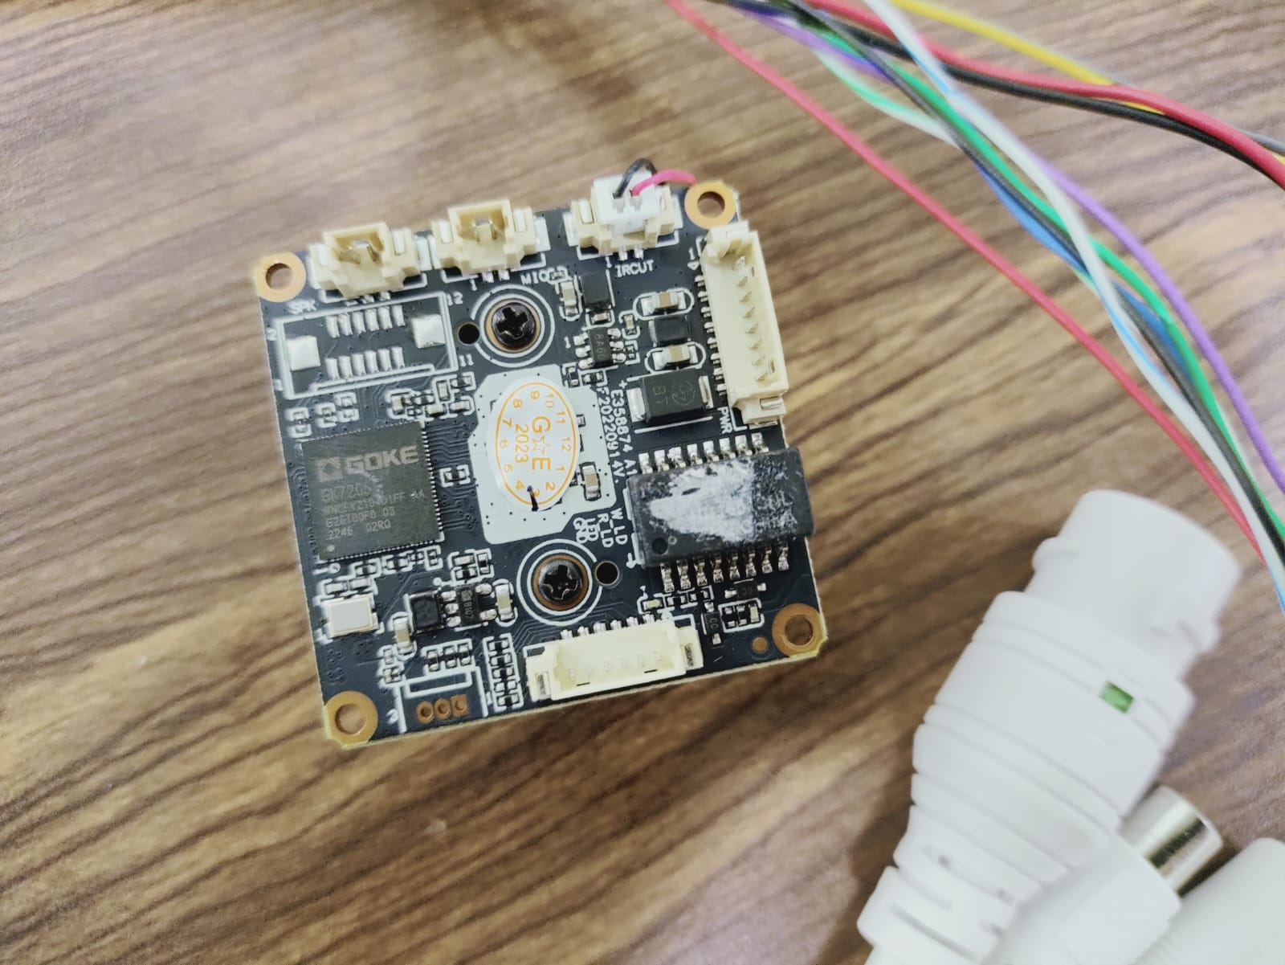

3) Poe Cable & Power adaptor  
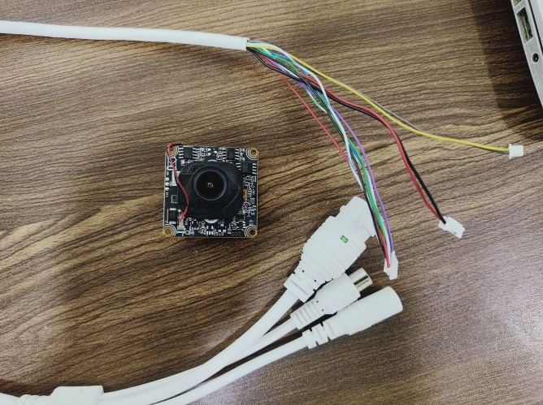

Software Required (Install into your windows 10 )  
  
1) PowerShell  
2) Putty  
3) Tftpd  
4) winscp  
5) Python and its dependencies ( progressbar , pyserial)   
Make sure environment variable is updated for python. To verify the python installation, open PowerShell app and type “python –V” if it returns version then python is working fine in your system. You can install dependency by typing commands like “pip install progressbar” or “python -m pip install progressbar”

Steps to connect hardware  
  
1) Find the Rx,Tx,G on PCB   
  
Here Red mark is Rx , Green is Tx and Blue is Ground  
2) Solder one side of three wires (Jumper wires) on all these 3 points  
If you are not perfect in soldering then try simple hack by using stapler pins (Shown in below pic). Pins should not touch each other.  
 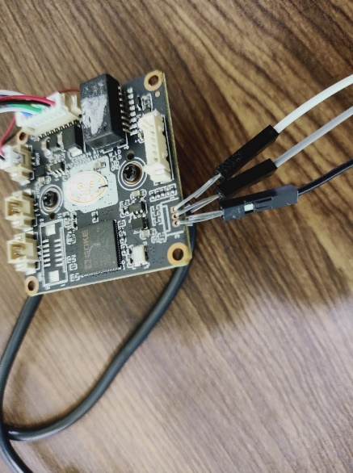

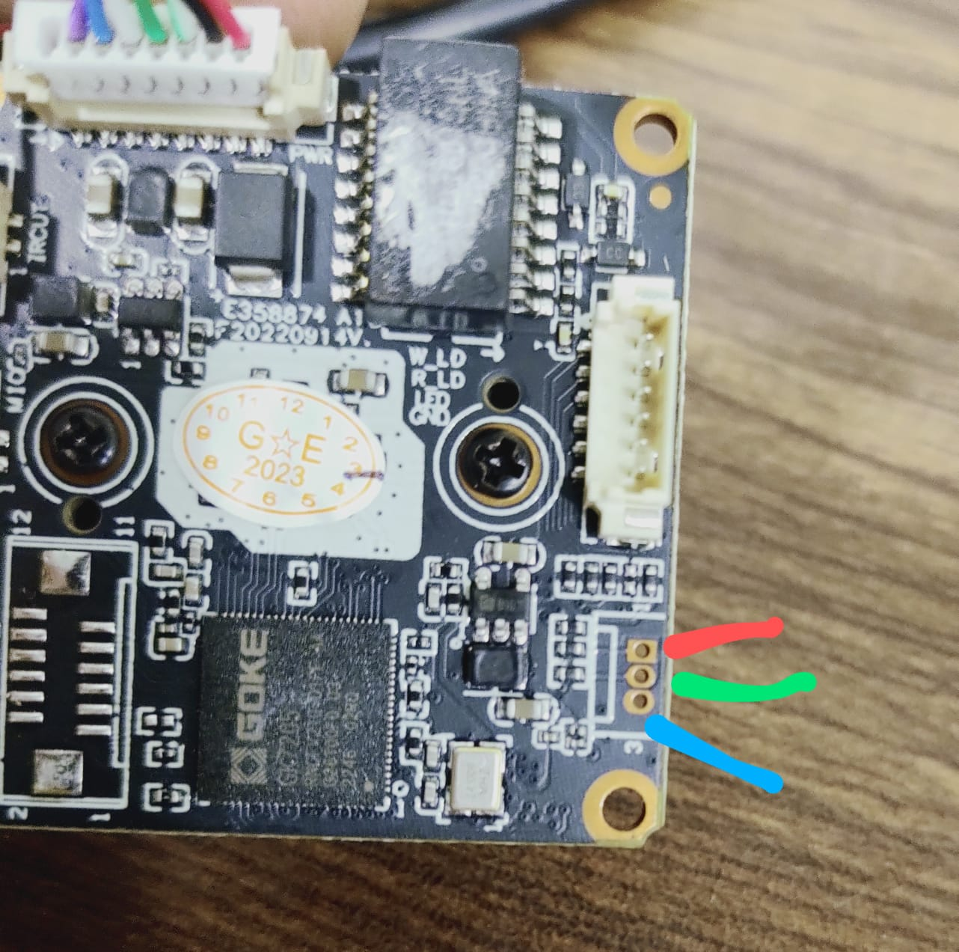

3) Connect another sides of jumper wires into UART as shown in pic below.  
  
Note: Switch Jumper into 3.3v (Marked in green arrow)  
Connect Rx wire of PCB into Tx on UART and Tx of PCB into Rx on UART  
4) Connect UART with Laptop by USB   
5) Connect LAN cable to camera (Assuming other side of LAN cable connected with router and your laptop is also connected with same router [with wifi or LAN]). Both laptop and camera should be connected in same local network  
  
  
Steps at software side.  
  
1) Open “System Device Manager” to check COM port number , to which UART connected.  
   
  
Here it connected at COM10  
2) Download openIPC burn files at <https://github.com/OpenIPC/burn/archive/refs/heads/master.zip>   
Unzip, rename it “burn” an place it location C:\  
So it makes path like C:\burn\  
Download u-boot file at https://github.com/OpenIPC/firmware/releases/  
Download .bin file of your processor.  
In my case it is <https://github.com/OpenIPC/firmware/releases/download/latest/u-boot-gk7205v200-universal.bin>  
place u-boot-gk7205v200-universal.bin at location C:\burn\  
You can also rename it like ubootgk7205v200universal.bin (Remove – sign)  
Now u-boot file path is C:\ubootgk7205v200universal.bin

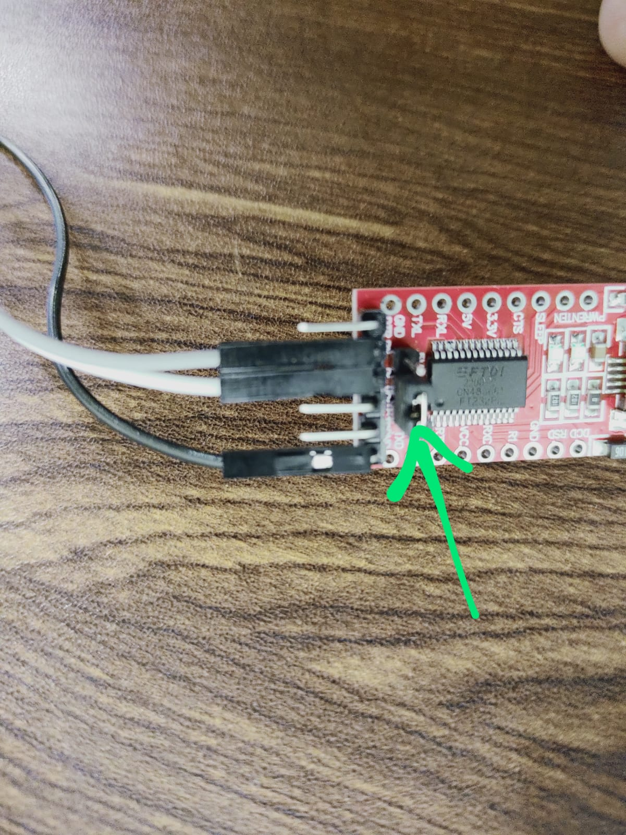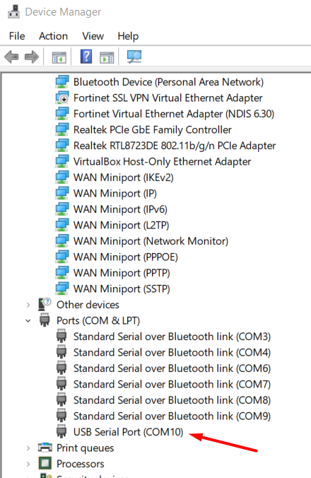

3) Download firmware  
Visit <https://openipc.org/supported-hardware/featured>   
Click on docs icon of your processor  
In my case it redirect to <https://openipc.org/cameras/vendors/goke/socs/gk7205v210>  
Generate Macaddress, Select Memory chip, change camera and your laptop ip address. Click on generate installation instructions.  
Note: you can check laptop ip address by command ipconfig  
To verify assigned ip to camera you can check it with their default firmware or by default app. In my case my camera support **xmeye** app.  
I installed the app in my android phone (Phone is connected with same router by wifi) then find option to add camera then add camera by searching local network. It will show available device (camera) and its ip address.  
  
Now scroll down the page (See below pic)  
  
You will get download link of firmware. Download it and place the downloaded file at location c:\tftpd (Create tftpd folder if not exist)

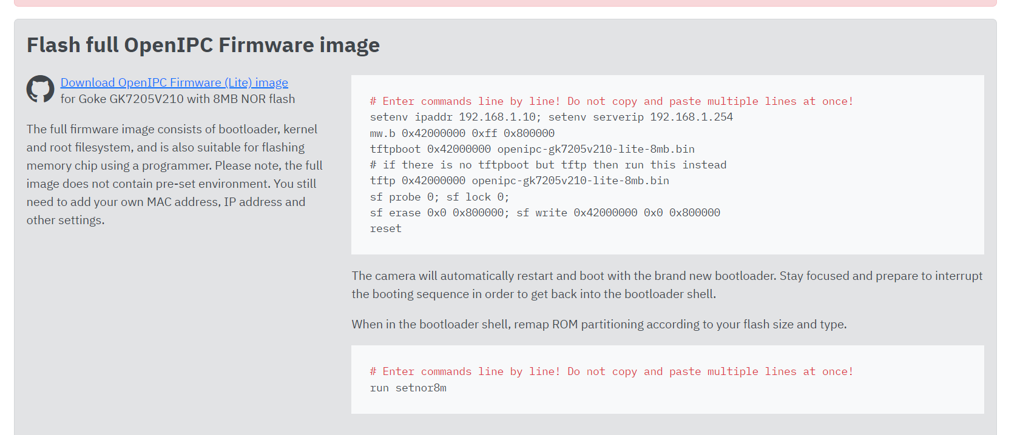

4) Setup tftpd for file transfer.  
Open tftpd application, go to setting, select base directory c:\tftpd   
Select TFTPD security “none”  
Bind TFTPD to ip address -> Select your laptop ip address

Click ok and it may ask to reload the application. Click Ok.  
Now in main windows select correct ip address of laptop (Server interface option)   
Verify Current directory is c:\tftpd  
Click on “Show Dir” button to verify that your firmware file is visible. Then click “Close” button.  
See below pic.

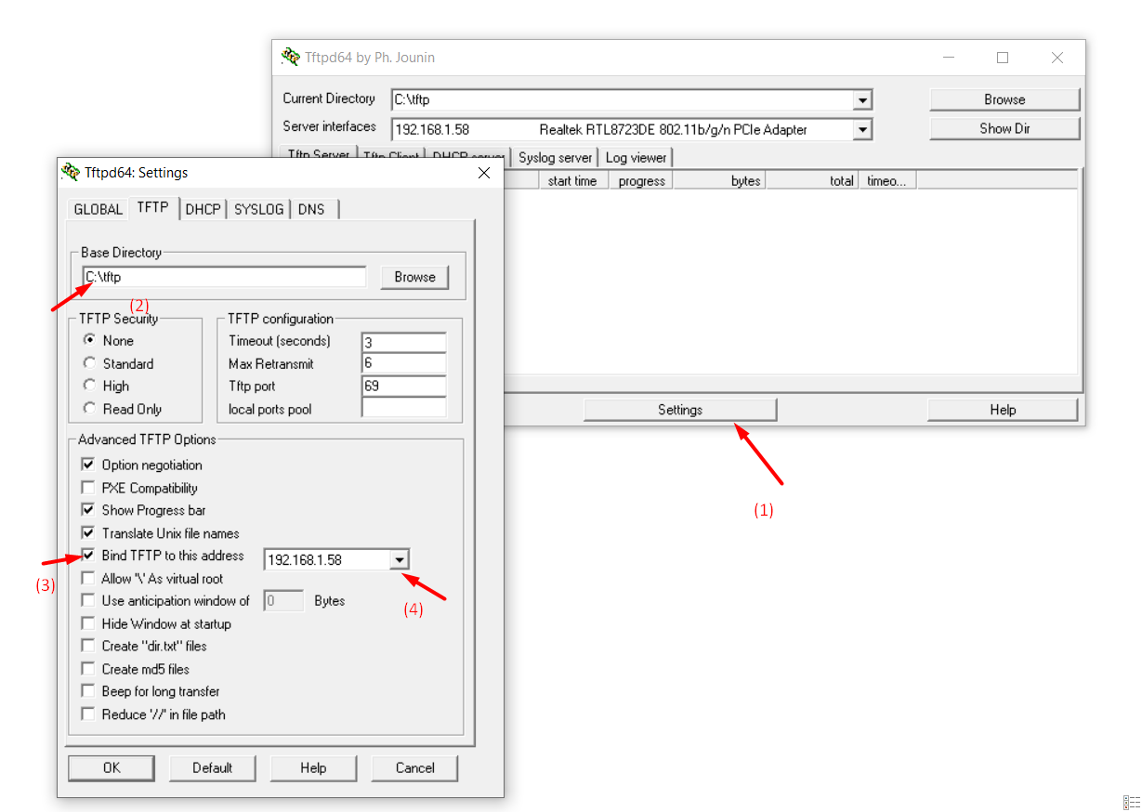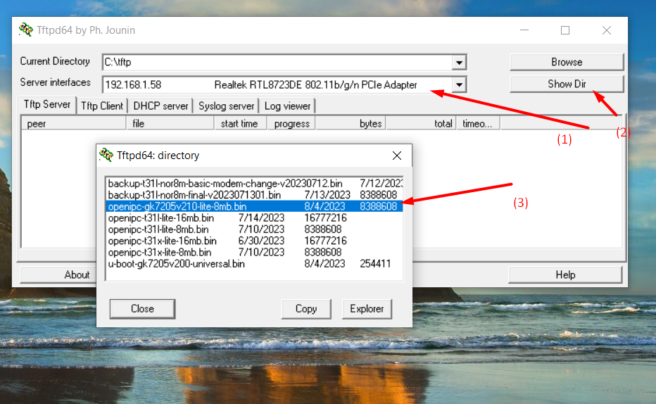

Start writing firmware  
1) Open two instances of power shell app  
In first instance enter to the location c:\burn   
Type command   
cd C:\burn  
Turn on the camera (Power on)  
Then type command  
python burn --chip gk7205v200 --file=ubootgk7205v200universal.bin -p COM10 --break  
It starts copying u-boot files  
Note: If it doesn’t start the copy (Showing trying to open COM10 then turn off-on camera power again – Without closing or cancel the command)  
In case you got any error of json file then check json file data and correct it ..

If file has name of other json file then copy the data from that file and save it..

When it completed the copy then in 2nd instance of powerShell app run following command  
Putty.exe -serial COM10 -sercfg 115200,8,n,1,N   
Terminal window of putty will popup to enter further commands.  
You have to click on cursor and press enter key to get openipc#

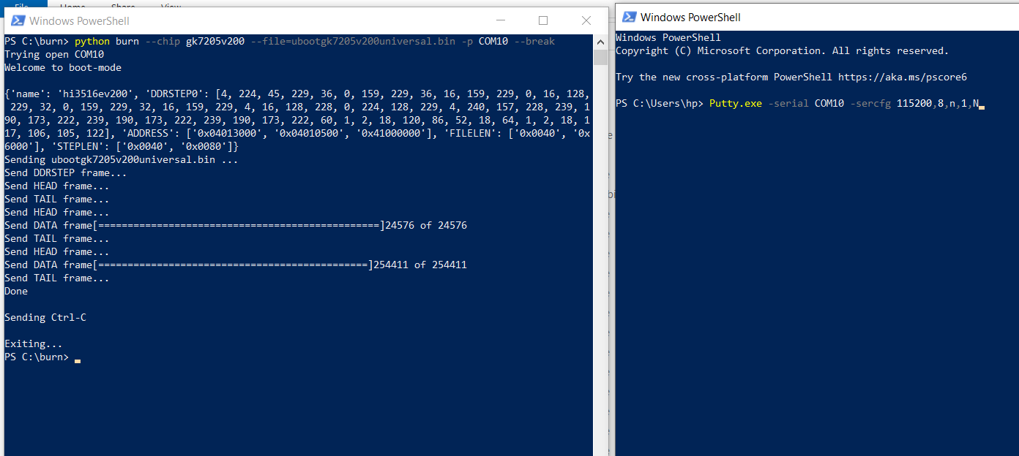

Copy these commands which we generated on step “3) Download firmware”  
# Enter commands line by line! Do not copy and paste multiple lines at once!

setenv ipaddr 192.168.1.104; setenv serverip 192.168.1.58  
# in above commands ip should be correct, otherwise it will not copy the firmware files.

mw.b 0x42000000 0xff 0x800000

tftpboot 0x42000000 openipc-gk7205v210-lite-8mb.bin

sf probe 0; sf lock 0;

sf erase 0x0 0x800000; sf write 0x42000000 0x0 0x800000

reset  
  
when you enter reset it reboot the camera and you have to immediately interrupt the u-boot by pressing ctr + c key.  
Then type command   
  
run setnor8m

If it ask you to login then it mean  
OpenIPC installed!  
Default username is root  
Password is 12345  
  
To open the web view type url in browser like:   
<http://ipAddressOfCamera:85>  
Note: Ip address may be changed when openIPC installed so to verify the current ip address. Type ip address in terminal and check ipv4 ip